Computer Science

**Purchase Verification Form**

## **PURCHASER: Please complete the information below and attach receipt(s), or send the completed form via email along with a detailed description of your purchase request.**

1. Provide a detailed description of items purchased/to be purchased:

Following is a Digi-Key cart link:

<http://www.digikey.com/short/3fv4nt>

Subtotal: $76.56

A Sparkfun Teensy 3.5 with Headers Board

<https://www.sparkfun.com/products/14056>

Subtotal: $28.95

Attached also: PCB Gerber Files for 33$ Standard Student board from Advanced Circuits, with standard 10$ pickup.

Subtotal: $43.00

Total $149.51

Note: If the link provided does not work please contact Kyle at kyle.harlow@colorado.edu

1. Provide the detailed business purpose of the purchase (“to support research/teaching” is not detailed enough):

The components on the parts list above are for building the merge board for the CU RoboSub AUV Ocean’s 7 Capstone Team

## Funding Source(s) to be charged, include name and/or speedtype:

11002242 EEF Correll Robosub

**For the purchases listed above, I certify that the transactions were all purchases for University of Colorado business and that no personal purchases were made. For sponsored project purchases, I also verify that the Cost is reasonable, allocable to the project, and treated consistently, that the item(s) will be used only for the project listed and that the cost is explicitly listed in the approved budget.**

**February 22, 2017**

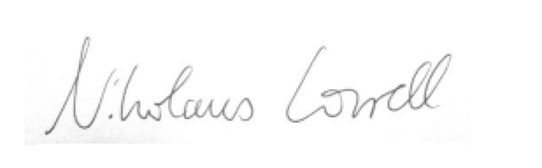

**Signature Date 2/22/2017**

For sponsored projects, if you are not the Principal Investigator and cannot attest to the above statement, please ask the Principal Investigator of the project to do so.